Card Clearing
# Source: AI Source: Provided by: [Data Path: Persons Table -> ID Column: 1, Name_En Column: Motasem Essam] -> From: [ChatGPT] on [1/21/2026]
Card clearing refers to the process of validating, matching, and preparing payment card transactions (credit, debit, or prepaid) for final settlement between banks. It is typically handled by card networks (like Visa, Mastercard, or domestic schemes), which act as clearing houses between the acquiring bank (merchant’s bank) and the issuing bank (customer’s bank).

🧠 Simple Definition
# Source: AI Source: Provided by: [Data Path: Persons Table -> ID Column: 1, Name_En Column: Motasem Essam] -> From: [ChatGPT] on [1/21/2026]
Card clearing is the stage where payment card transactions are confirmed and exchanged between the involved banks — via the card network — before the actual transfer of money (settlement) occurs.

🔁 Card Payment Lifecycle: Where Clearing Fits
# Source: AI Source: Provided by: [Data Path: Persons Table -> ID Column: 1, Name_En Column: Motasem Essam] -> From: [ChatGPT] on [1/21/2026]
- Authorization — Customer taps/swipes the card → transaction approved in real-time.
- Clearing — Transaction data is validated, matched, and recorded by the card network.
- Settlement — Funds move between issuing and acquiring banks (usually the next business day).

🎯 Key Roles in Card Clearing
# Source: AI Source: Provided by: [Data Path: Persons Table -> ID Column: 1, Name_En Column: Motasem Essam] -> From: [ChatGPT] on [1/21/2026]
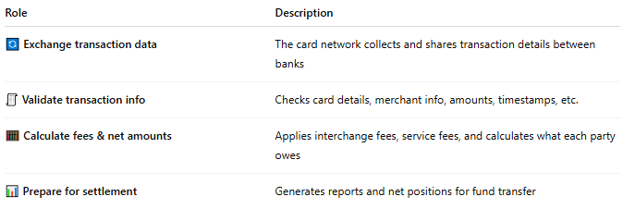

Role | Description
🔄 Exchange transaction data | The card network collects and shares transaction details between banks
🧾 Validate transaction info | Checks card details, merchant info, amounts, timestamps, etc.
🧮 Calculate fees & net amounts | Applies interchange fees, service fees, and calculates what each party owes
📊 Prepare for settlement | Generates reports and net positions for fund transfer

🌍 Examples of Card Clearing Networks
# Source: AI Source: Provided by: [Data Path: Persons Table -> ID Column: 1, Name_En Column: Motasem Essam] -> From: [ChatGPT] on [1/21/2026]
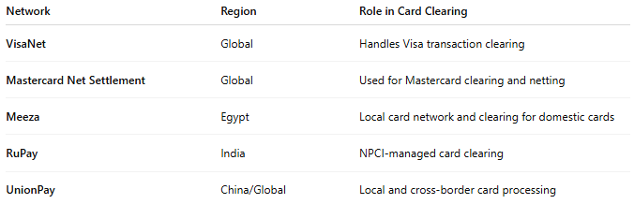

Network | Region | Role in Card Clearing
VisaNet | Global | Handles Visa transaction clearing
Mastercard Net Settlement | Global | Used for Mastercard clearing and netting
Meeza | Egypt | Local card network and clearing for domestic cards
RuPay | India | NPCI-managed card clearing
UnionPay | China/Global | Local and cross-border card processing

✅ Benefits of Card Clearing
# Source: AI Source: Provided by: [Data Path: Persons Table -> ID Column: 1, Name_En Column: Motasem Essam] -> From: [ChatGPT] on [1/21/2026]
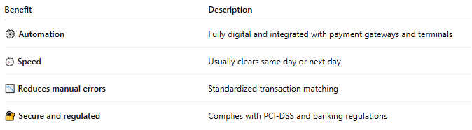

Benefit | Description
⚙️ Automation | Fully digital and integrated with payment gateways and terminals
⏱️ Speed | Usually clears same day or next day
📉 Reduces manual errors | Standardized transaction matching
🔐 Secure and regulated | Complies with PCI-DSS and banking regulations

⚠️ Risks & Considerations
# Source: AI Source: Provided by: [Data Path: Persons Table -> ID Column: 1, Name_En Column: Motasem Essam] -> From: [ChatGPT] on [1/21/2026]
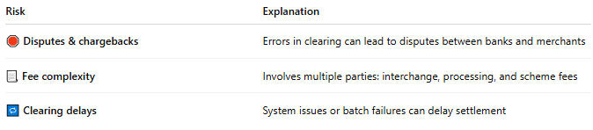

Risk | Explanation
🛑 Disputes & chargebacks | Errors in clearing can lead to disputes between banks and merchants
📃 Fee complexity | Involves multiple parties: interchange, processing, and scheme fees
🔁 Clearing delays | System issues or batch failures can delay settlement

🧠 Summary
# Source: AI Source: Provided by: [Data Path: Persons Table -> ID Column: 1, Name_En Column: Motasem Essam] -> From: [ChatGPT] on [1/21/2026]
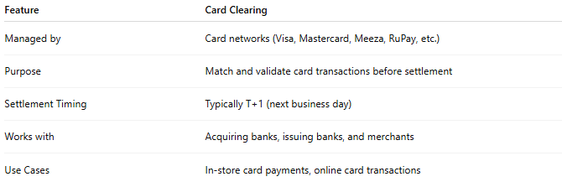

Feature | Card Clearing
Managed by | Card networks (Visa, Mastercard, Meeza, RuPay, etc.)
Purpose | Match and validate card transactions before settlement
Settlement Timing | Typically T+1 (next business day)
Works with | Acquiring banks, issuing banks, and merchants
Use Cases | In-store card payments, online card transactions

